Number of Smokers in the Last 20 Years: Analysis

Study conducted by:

Mounzer Awad

Senzo Buthelezi

Contents

Table of Figures 1

1- Objective 2

2- Design 2

3- Outcome measures 4

4- Parties of interest 4

5- Results 5

5.1- Cigarettes 5

5.2- Cigars 6

5.3- Pipes 7

5.4- Interaction between sex, year, and smoking status 8

Conclusion 11

References 12

# Objective

Has the number of Smokers in England Decreased in the last 20 Years? This is our research question, and according to the Department of Health and Social Care in England, smoking is the leading cause of health inequalities and accounts for half of the difference in life expectancy among the population (Care, 2024). Given this notion, it is important to investigate if England’s population is decreasing to levels that might negatively hinder economic and social indicators.

It is also important to note that APS research has been done on this research question, and it shows that the number of cigarette smokers in England has decreased in 2022 but other research points at increases in the 90s due to an array of economic policies being implemented and changes in social dynamics (ONS, 2024). Given these discrepancies, our findings are not obvious.

# Design

Cross-sectional data was used for this analysis. The data is for the years 1999 and 2019; both periods have sample sizes > 10000 respondents. However, given the Question we will be analyzing, we had to merge the two periods with variables of interest. These variables of interest can be found in table 1.

|  |  |
| --- | --- |
| Name | Labels |
| Sex | Sex |
| cigreg | How frequently used to smoke |
| cigdyal | Number of cigarettes smoked a day |
| Year | Year (1: 1999; 2: 2019) |
| cigsta | Cigarette smoking status: current/ex-reg/never-reg |
| cigarnow | Currently smokes cigars |
| cignow | Currently smokes cigarettes |
| pipenow | Currently smokes pipe |
| NRNow8_19 | Nicotine replacement product currently used: Electronic cigarette or vaping device |

Table 1- list of variables selected

Sex, cigreg, Year, cigsta, cigarnow, cignow, and pipenow are nominal variables. The variables’ categories can be found in table 2:

|  |  |
| --- | --- |
| Variable | Categories |
| Sex | 1: Male 2: Female |
| Year | 1: 1999 2: 2019 |
| cigreg | -9: Refused -8: Don’t know -6: Schedule not obtained -2: Schedule not applicable -1: Item not applicable 1: Regularly 2: Occasionally 3: Only tried once or twice 4: Haven’t stopped smoking |
| cigsta | -9: Refused -8: Don’t know -6: Schedule not obtained -2: Schedule not applicable -1: Item not applicable 1: Current cigarette smoker 2: Ex-regular cigarette smoker 3: Never regular cigarette smoker |
| Cignow, cigarnow, pipenow | -9: Refused -8: Don’t know -6: Schedule not obtained -2: Schedule not applicable -1: Item not applicable 1: Yes 2: No |

Table 2- nominal variables and their categories

# Outcome measures

Our null and alternative hypotheses were:

Ho: The proportion of smokers in England has not changed between 1999 and 2019

H1: The proportion of smokers in England has decreased between 1999 and 2019

A chi-squared test was done on SPSS because the variables of interest followed these assumptions:

* Independent variables are categorial
* Dependent variables are also categorial
* The observations are independent of every other observation because it is free from political or commercial biases, allowing for unbiased data collection and analysis that can inform public health policy and service planning
* Categories within each cell are mutually exclusive, meaning each individual can only belong to one category in each variable. **Not sure**
* The expected frequency of each cell should be at least 5. This ensures that the chi-squared distribution is a good approximation of the test statistic distribution.

# Parties of interest

The study is of interest of stakeholders in the health sector since it allows us to address public health concerns, Policy intervention, Economic implications, and social trends.

Public health concerns: Smoking has negative health implications, such as heart disease and lung cancer so monitoring its consumption is beneficial for intervention planning.

Policy evaluation: Given its negative implications, England, like many nations, uses laws such as smoking restrictions and Economic policies like sin tax to curb cigarette use.

Economic and Financial implications: Smoking has significant economic costs, including healthcare expenses and lost productivity/labor. Reducing the number of smokers can lead to substantial economic benefits, making this research question relevant to economists and healthcare funders.

Social trends: Changes in smoking prevalence can reflect broader social trends, such as shifts in public attitudes towards health and wellness. This information is valuable for sociologists and market researchers.

# Results

The primary study to answer the research question was done for the dependent variables ‘cignow’ (current use of cigarettes), ‘cigarnow’ (current use of cigars), and ‘pipenow’ (current use of pipe) and independent variable Year. Since both sets of variables are categorical (nominal) and align with the assumptions of the Chi-Squared test highlighted earlier, a Chi-Squared test was conducted to analyse the variables in the two separate years (1999 and 2019) to see if any statistically significant differences were found.

## 5.1- Cigarettes

As can be seen in figure 1, the count of ‘yes’ replies when survey takers were asked if they were currently smoking cigarettes were 1519 and 1254 for the years 1999 and 2019 respectively. The subscripts a and b denote the subset of Year categories whose column proportions do not differ significantly from each other at the 0.05 level.The fact that the two subscripts are different mean that the two counts do indeed differ significantly from each other. As can be verified in figure 2, highlighting the Chi-Squared test results of the pair, there is evidence to believe that the number of people smoking cigarettes have differed between 1999 and 2019; and the fact that the count found under 2019 is less than that of 1999 means that the number of cigarette smokers have decreased in the past 20 years.

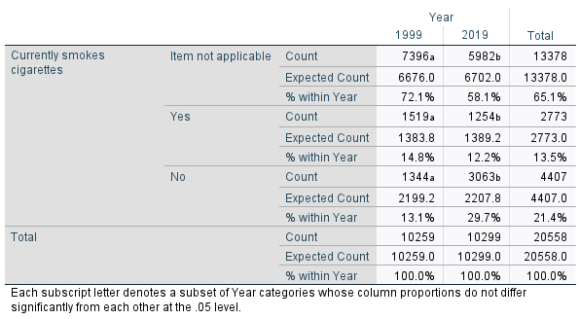

Figure 1- Crosstab of cignow and year

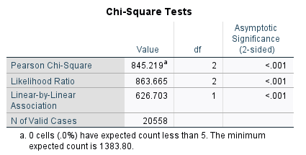

Figure 2- Chi-Squared test results for cignow and year

## 5.2- Cigars

Similar to cigarettes, the same conclusion was reached by observing the counts of the ‘Yes’ category under both years in figure 3. The year 1999 had 180 survey takers that were currently smoking pipes and in 2019 that number was 115. Both counts have different subscripts which signify the fact that the column proportions differ significantly from each other at the 0.05 level. The case is evident with the Pearson Chi-Square significance being <0.01 which suggests that there is indeed a significant difference in proportions. The fact that the number of cigar smokers in 2019 is less than that in 1999 suggests that the number of cigar smokers have decreased in the past 20 years.

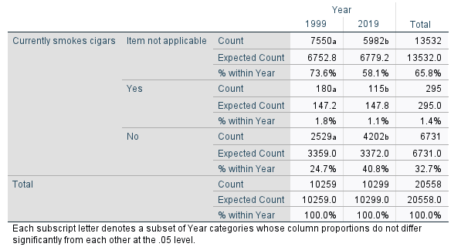

Figure 3- Crosstab of cigarnow and year

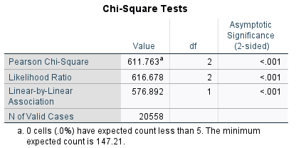

Figure 4- Chi-Squared test results for cigarnow and year

## 5.3- Pipes

In the case of the use of pipes in the past 20 years. The Pearson Chi-Squared significance value is significant (<0.001), as can be found in figure 6; this suggests that there is one significant difference in proportions between the columns. Observing the counts in the ‘Yes’ category in figure 5, the number of pipe users in 1999 and 2019 is 24 and 19 respectively. While the number is less in 2019, the two values have the same a subscript, which means that the column proportions of this category do not differ significantly between 1999 and 2019.

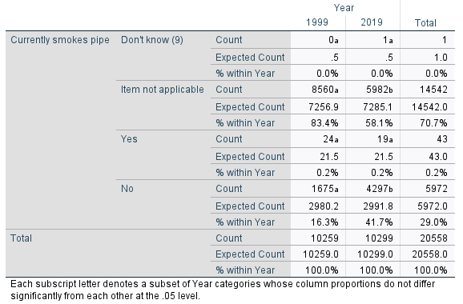

Figure 5- Crosstab of pipenow and year

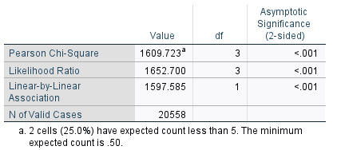

Figure 6- Chi-Squared test results for pipenow and year

## 5.4- Interaction between sex, year, and smoking status

Having concluded that the number of smokers in England has decreased between the two periods, we decided to do a deep dive into sexes and how they were represented in the overall viewpoint. The Pearson Chi-Squared significance values are all less than 5% for both years meaning there is no significant difference between the variables, as per figure 8. This can also be recorded as χ2 (2) = 330.481, p < 0.001) for 1999 and χ2 (2) = 41.365, p < 0.001) for 2019. It is interesting to note that the number of women who smoke increased between 1999 and 2019 while it decreased for males. As can be seen in figure 7, the count of men who smoke has decreased from 1999 to 2019 (from 989 to 611) since the counts have different subscripts; and as established earlier, the different subscripts denote that there is a significant difference between the columns. While the same can be said for women in terms of a significant difference; however, the number of smokers has increased from 530 to 643.

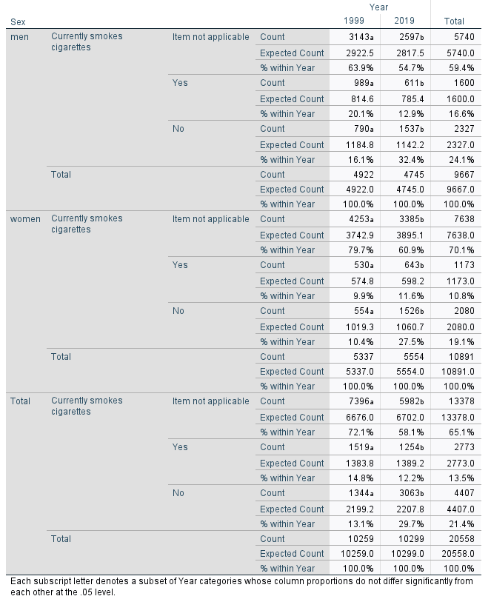

Figure 7- Crosstab results for cignow and year, sex

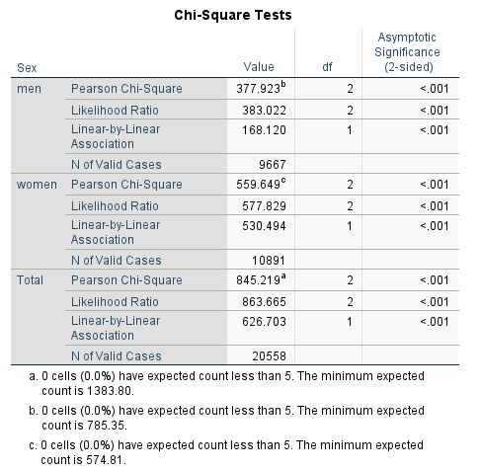

Figure 8- Chi-Squared test results for cignow and year, sex

# Conclusion

Our research question was if the number of smokers had decreased between 1999 and 2019, we found that the overall trend pointed to a decrease in the number of smokers in England. This was achieved using a chi-squared test while adhering to the assumptions when using such a test for analysis. From the desk research done on smoking trends in England, this decrease can be attributed to several factors such as “Stoptober” which gives smokers the perfect opportunity to quit smoking (Care, 2024), and government initiatives that involve increasing tobacco duty to discourage the consumption of cigarettes through a price increase (Keep, 2024).

Apart from the cigarette consumption decreasing within our period we also observed that the consumption of cigars decreased while the use of pipes did not change but this is insignificant given that pipe smokers have low numbers that don’t exceed a count of 25 within our sample.

While the sample studied does not reflect on the whole population, the data revealed that the number of female cigarette smokers has increased as opposed to a decrease for males. This is a critical insight because an increase in female smokers could result in a decreasing population/labour force which can lead to economic downturns and negative social outcomes.

# References

Care, D. o. (2024, October 9). *Fingertips, public health profiles*. Retrieved from Department of Health & Social Care: https://fingertips.phe.org.uk/profile/tobacco-control/supporting-information/smokingandinequalities

Care, D. o. (2024, October 10). *Stopping the start: our new plan to create a smokefree generation*. Retrieved from Uk Government Publications: https://www.gov.uk/government/publications/stopping-the-start-our-new-plan-to-create-a-smokefree-generation/stopping-the-start-our-new-plan-to-create-a-smokefree-generation

ONS, O. f. (2024, October 9). *Adult smoking habits in the UK: 2022*. Retrieved from ONS: https://www.ons.gov.uk/peoplepopulationandcommunity/healthandsocialcare/healthandlifeexpectancies/bulletins/adultsmokinghabitsingreatbritain/2022#:~:text=Based%20on%20APS%20data%2C%20the,20.2%25%20of%20the%20population).

Statista. “UK Cigarette Prices (RRP) 2005-2017 | Statista.” *Statista*, Statista, 2017,

www.statista.com/statistics/414973/cigarette-prices-in-the-united-kingdom/.

Keep, Matthew. *Tax Statistics: An Overview*. 10 May 2024.

# Table of Figures

Figure 1- crosstab of cignow and year 5

Figure 2- Chi-Squared test results for cignow and year 6

Figure 3- crosstab of cigarnow and year 6

Figure 4- Chi-Squared test results for cigarnow and year 7

# Table of Tables

Table 1- list of variables selected 2

Table 2- nominal variables and their categories 3